Discipline “Molecular biotechnology of prokaryotes and eukaryotes”
Program of Seminar
Seminar 1. Main approaches and methods of molecular biotechnology In prokaryotes, DNA is usually contained in a single, circular chromosome.
Seminar 2. Mediated trasduction, plasmid-mediated conjugation, natural transformation.
Seminar 3 Analysis and Characterization of nucleic acids. The Significance of Amplification Techniques
Nucleic acid amplification and serological techniques for the diagnosis of infectious disease have complementary characteristics. Because amplification methods directly detect minute quantities of pathogen genetic material, they can pro-vide acute phase diagnosis with high sensitivity without the need to await antibody formation.
Amplification methods will detect a pathogen only if nucleic acid from that organism is actually present, so confusion with infections in the distant past is unlikely.
Serology may also be used to determine whether apatient has been exposed to a pathogen, regardless of whether the infecting organism is actually present, whereas amplification methods require the presence of the organism. An antibody response also provides information on the pathogenicity or invasive-ness of an organism such as Legionella sp. which may be normally present in the environment and thus contain clinical specimens.
PCR is used widely in:
- Molecular cloning
- Pathogen detection
- Genetic engineering
- Mutagenesis
- Genetics, producing molecular markers
- Forensics.
Variations - starting or ending with SS nucleic acids
- rt-PCR starts with RNA and reverse transcriptase
- PCR Sequencing - single strands generated by
an excess of one primer.
Fidelity
• Primer annealing (hybridization) specificity
depends on:
- primer length
- match to template sequences
- (degenerate primers)
- GC content of the primer
- heterogeneity of the DNA sample
  - Polymerase reaction
- Intrinsic enzymatic fidelity, proofreading
- ability.
- Solution conditions, dNTP pools
Seminar 4. Understanding RNA world hypothesis and Peptide-RNA world terms.
Seminar 5. Polyphyletic of prokaryota comprising bacteria and archaea.
Seminar 6. The domain eukaryota is monophyletic. Genetic recombination during meiosis.
Seminar 7. Chromosome scaffold.
What is Chromatin? Euchromatin? Heterochromatin?
2. What functionally can Eucharomatin do that Heterochromatin can not do?
3. Why are Telomeres absent from prokaryotic chromosomes?
4. What is the basic structure of a Telomere? Correlate this structure with the 2 functions of a Telomere.
5. Discuss the different types of chromosome
6. List the different types chromosome abnormalities
Seminar 8. Molecular structure of plastids.
Seminar 9. Genome mapping, genetic mapping, physical mapping, mapping distance. DNA Sequencing techniques.
Introduction
Linkage occurs when genes are on the same chromosome. When genes occur on the same chromosome, they are inherited as a single unit.
Genes inherited in this way are called Linked.
Genes are located on specific regions of a certain chromosome, termed the gene locus (plural: loci). A
gene therefore is a specific segment of the DNA molecule.
Linkage groups are invariably the same number as the pairs of homologous chromosomes an organism possesses. Recombination occurs when crossing over has broken linkage groups, as in the case of the genes for wing size and body color that Morgan studied.
Chromosome mapping was originally based on the frequencies of recombination between alleles.
- Describe methods used for analysis of linkage
- ⇒ explain the mechanism underlying linkage
- ⇒ describe role of Linkage in genetic make up
- ⇒ describe how linkage between genes or between genes and markers can be established in human populations
- ⇒ discuss risk assessment of X-linked recessive, autosomal recessive and autosomal dominant disorders using linked markers.
- ⇒ discuss the limitations of a marker analysis.
- ⇒ describe genetic recombination and discuss its effects on genetic analysis and testing.
Seminar 10. Chromosome scaffold.Centromere sequences.
Cytogenetic analyses are almost always based on examination of chromosomes fixed during mitotic
metaphase. During that phase of the cell cycle, DNA has been replicated and the chromatin is highly
condensed. The two daughter DNAs are encased in chromosomal proteins forming sister chromatids, which are held together at their centromere.
Metaphase chromosomes differ from one another in size and shape, and the absolute length of any one chromosome varies depending on the stage of mitosis in which it was fixed. However, the relative position of the centromere is constant, which means that that the ratio of the lengths of the two arms is constant for each chromosome. Centromere position and arm ratios can assist in identifying specific pairs of chromosomes, but inevitably several or many pairs of chromosomes appear identical by these criteria.
The ability to identify specific chromosomes with certainty was revolutionized by discovery that certain dyes would produce reproducible patterns of bands when used to stain chromosomes. Chromosome banding has since become a standard and indispensable tool for cytogenetic analysis, and
several banding techniques have been developed:
Q banding: chromosomes are stained with a fluorescent dye such as quinacrine
• G banding: produced by staining with Giemsa after digesting the chromosomes with trypsin
• C banding: chromosomes are treated with acid and base, then stained with Giesma stain Each of these techniques produces a pattern of dark and light (or fluorescent versus nonfluorescent) bands along the length of the chromosomes.
Importantly, each chromosome displays a unique banding pattern, analogous to a "bar code", which allows it to be reliably differentiated from other chromosomes of the same size and centromeric position.
Seminar 11. DNA fingerprinting. Exon shuffling. mobile DNA elements
Seminar 12. Mobile genetic DNA.
Mobile genetic elements (MGEs) are a type of genetic materials that can move around within a genome, or that can be transferred from one species or replicon to another. MGEs are found in all organisms. In humans, approximately 50% of the genome is thought to be MGEs. MGEs play a distinct role in evolution. Gene duplication events can also happen through the mechanism of MGEs. MGEs can also cause mutations in protein coding regions, which alters the protein functions. In addition, they can also rearrange genes in the host genome. One of the examples of MGEs in evolutionary context is that virulence factors and antibiotic resistance genes of MGEs can be transported to share them with neighboring bacteria. Newly acquired genes through this mechanism can increase fitness by gaining new or additional functions. On the other hand, MGEs can also decrease fitness by introducing disease-causing alleles or mutations.

Types of mobile genetic elements
- Transposons (also called transposable elements) are DNA sequences that can move locations within a genome, which includes retrotransposons and DNA transposons.
  - Retrotransposons are the most widespread class of transposons in mammals. An RNA transcript of MGEs is copied by reverse transcriptase. Then, the DNA sequence can be inserted back to a random location of the genome.
  - DNA transposons are a DNA segment that can move to a new location by a “cut-and-paste” strategy.
- Plasmids of bacteria are a transferable genetic element through bacterial conjugation. This is a mechanism of horizontal gene transfer that allows bacteria to share virulence factors and antibiotic resistance genes.
- Bacteriophage elements, like Mu, which integrates randomly into the genome by transduction.
- Group I and II introns are a product from self-splicing in the host transcripts, and they act as ribozymes that can invade tRNA, rRNA, and protein coding genes in bacteria

Research examples
CRISPR-Cas systems in bacteria and archaea are adaptive immune systems to protect against deadly consequences from MGEs. Using comparative genomic and phylogenetic analysis, researchers found that CRISPR-Cas variants are associated with distinct types of MGEs such as transposable elements. In addition, CRISPR-Cas controls transposable elements for their propagation.
CRISPR-Cas (clustered regularly interspaced short palindromic repeats) is a family of DNA sequences found within the genomes of prokaryotic organisms such as bacteria and archaea. These sequences are derived from DNA fragments of viruses that have previously infected the prokaryote and are used to detect and destroy DNA from similar viruses during subsequent infections. Hence these sequences play a key role in the antiviral defense system of prokaryotes
MGEs such as plasmids by a horizontal transmission are generally beneficial to an organism. The ability of transferring plasmids (sharing) is important in an evolutionary perspective. Tazzyman and Bonhoeffer found that fixation (receiving) of the transferred plasmids in a new organism is just as important as the ability to transfer them. Beneficial rare and transferable plasmids have a higher fixation probability, whereas deleterious transferable genetic elements have a lower fixation probability to avoid lethality to the host organisms.
Transposition by transposable elements is mutagenic. Thus, organisms have evolved to repress the transposition events, and failure to repress the events causes cancers in somatic cells. Cecco et al. found that during early age transcription of retrotransposable elements are minimal in mice, but in advanced age the transcription level increases. This age-dependent expression level of transposable elements is reduced by calorie restriction diet.
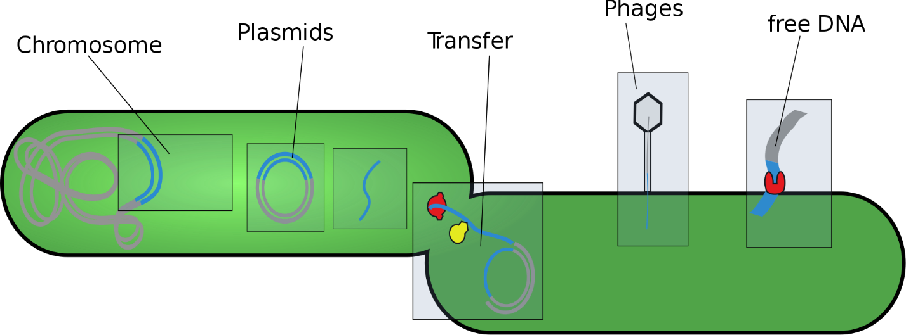

Seminar 13. Chromosomal organization of genes and noncoding DNA
- What is a Chromosome? • is a structure that occurs within cells and that contains the cell's genetic material.
- Each chromosome has a constriction point called the centromere, which divides the chromosome into two sections, or “arms.” • The short arm of the chromosome is labeled the “p arm.” • The long arm of the chromosome is labeled the “q arm.” • The location of the centromere on each chromosome gives the chromosome its characteristic shape, and can be used to help describe the location of specific genes.
- Eukaryotic Chromosomes • The eukaryotic chromosomes differ from the prokaryotic chromosomes in morphology, chemical composition and molecular structure. • The eukaryotes (plants and animals) usually contain much more genetic informations than the viruses and prokaryotes, therefore, contain a great amount of genetic material. • DNA molecule which here may not occur as a single unit, but, as many units called chromosomes.
- Different species of eukaryotes have different but always constant and characteristic number of chromosomes. • In eukaryotes, nuclear chromosomes are packaged by proteins into a condensed structure called chromatin. • This allows the very long DNA molecules to fit into the cell nucleus.
- Chemically, the eukaryotic chromosomes are composed of deoxyribonucleic acid (DNA), ribonucleic acid (RNA), histone and non-histone proteins and certain metallic ions. Molecular Structure of Chromosomes Chemical structure of DNA
- There are two DNA chains in one chromosome • DNA has four bases A, G, T and C. • A combined with T and G combined with C
- Normal cell division—Mitosis • Old cells died and new cells grow. The new cells grow through normal cell division. • The normal cell division—Mitosis process: (1). The double DNA strands in each of the chromosomes split into two single-strands. (2). DNA replication. After step (2), each chromosome produces another identical one.
- All the 23 pairs of the chromosomes undergo this process of replication, producing two identical sets of 23 chromosome pairs. • The two sets of chromosomes are separated and distributed into two daughter cells.
- The inheritance of chromosomes—Meiosis 1. The 23 pairs of chromosomes in the cell are duplicated every time a cell division occurs. 2. The only exceptions to this rule are gametes (ovum and sperm), which are produced by sex organ. 3. Gametes are produced by a special cell division called Meiosis. 4. Meiosis gives rise to daughter cells (ovum or sperm) which contain only a haploid (single chromosome, not pair) set of 22 autosomes and a sex chromosome.
- Human chromosomes • In humans, each cell normally contains total of 46. • Twenty-two of these pairs, called autosomes, look the same in both males and females. • The 23rd pair, the sex chromosomes, differ between males and females. Females have two chromosome, while males have one X and one Y chromosome.
- The 22 autosomes are numbered by size. • The other two chromosomes, X and Y, are the sex chromosomes.
- Variations in Chromosome Number & Structure • Normal number of chromosomes called euploid; different numbers called aneuploid. Types of aneuploidy 1. nullisomy—missing a pair of chromosomes so 2n-2 2. monosomy—missing 1 chromosome so 2n-1 (i.e. Turner XO female) 3. trisomy—an extra chromosome so 2n+1 (i.e. trisomy 21) 4. tetrasomy—2 extra chromosomes so 2n+2 -Consequences of aneuploidy in meiosis often serious or fatal, especially in humans
- Variations in Chromosome Structure There are two primary ways in which the structure of chromosomes can be altered: 1- The total amount of genetic information in the chromosome can change a- Decrease: Deficiencies/Deletionsloss of a chromosomal segment b- Increase: Duplications & Insertions:repetition of a chromosomal
- 2- The genetic material may remain the same, but its rearranged: a- Inversions: A change in the direction of genetic material along a single chromosome b- Translocations: A segment of one chromosome becomes attracted to a nonhomollogous chromosome 1- Simple translocations : One way transfer 2- Reciprocal translocations: Two way transfer
Seminar 14. Morphology and functional elements of eukaryotic chromosomes.
Describe the normal and abnormal chromosome morphology
⇒ list the factors which affect the relative recurrence
risk for a multifactorial (polygenic) trait within a family;
⇒ describe the various tissues which may be used to produce chromosome preparations
⇒ identify associated risks to carriers of structurally rearranged chromosomes. .
⇒ discuss chromosome abnormalities and their relevance to diagnosis, prognosis and disease
progression.
⇒ interpret a karyotype, describe the standard notation, specify the nature of any abnormalities;
⇒ identify the major clinical features and specific genetic errors responsible for the following
disorders: Down syndrome; Klinefelter syndrome; Prader-Willi syndrome; Turner syndrome.
Metacentric chromosomes have short and long arms of roughly equal length with the centromere in the middle.
Submetacentric chromosomes have short and long arms of unequal length with the centromere
more towards one end.
Acrocentric chromosomes have a centromere very near to one end and have very small short
arms. They frequently have secondary constrictions on the short arms that connect very small pieces of DNA, called stalks and satellites, to the centromere. The stalks contain genes which code for ribosomal RNA.

Seminar 15. Organization of Light-Chain DNA
Antibodies are produced by a class of leukocytes (white blood cells) called B lymphocytes, or B cells. The genes encoding antibodies with different binding specificities are not directly inherited from the fertilized egg. Rather, they are assembled from a number of separated gene segments present in germ-line DNA; this process occurs during the development of B cells from stem cells in the bone marrow. For example, a functional rearranged gene encoding the κ light chain (the major type of light chain in mice and humans) contains three segments. At the 5′ end is the L_{κ} segment; it encodes a leader or signal peptide that directs the newly translated protein into the endoplasmic reticulum in preparation for secretion from the cell. The signal peptide is removed during post-translational processing of the light chain and is not present in the mature antibody molecule. The second segment encodes the V_{L} domain of the light chain, and the third segment, at the 3′ end, encodes the C_{L} domain.
The DNA of germ cells (i.e., sperm and egg cells) and all other cells except mature B lymphocytes contains a κ locus that has a variable region at its 5′ end. This region consists of a library of leader (L_{κ}) and variable (V_{κ}) segments containing ≈100 L_{κ} + V_{κ} units in humans; these units are arrayed in tandem along one long stretch of DNA. (The L_{κ} segment corresponds to the leader exon in the final gene; the V_{κ} segment makes up most, but not all, of the final V_{L} exon, encoding the variable region of the light chain.) Each of the L_{κ} + V_{κ} units is about 400 nucleotides long, and they are separated by about 7 kb; thus 100 L_{κ} + V_{κ} units would cover about 740 kb of DNA. The variable region of the κ locus is followed by five joining (J_{κ}) segments in human germ-line DNA and then by the one constant (C_{κ}) segment. The five J_{κ} segments are tandemly arranged and are separated by about 20 kb from the 3′ end of the variable region. Each of the J_{κ} segments is about 30 nucleotides long, and they are spread over 1.4 kb of DNA. Between the 3′ J_{κ} segment and the single C_{κ} segment lies 2.4 kb of intervening DNA. The number of V_{κ} and J_{κ} segments varies with the species of mammal, although there are always many more V_{κ} than J_{κ} segments.
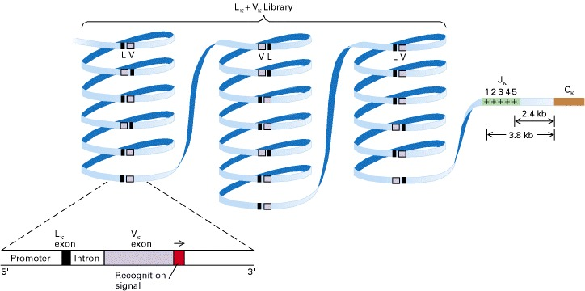
Organization of the κ light-chain locus in human germ-line DNA. In a library spread over hundreds of kilobases of DNA, there are about 100 V_{κ} segments, each with a unique sequence. The V_{κ} segments occur in both transcriptional.

Rearrangement of Light-Chain DNA
When DNA reorganizes to make a functional κ gene, one V_{κ} segment joins to one J_{κ} segment. This joining is performed by a sitespecific recombinase that recognizes sequences at the 3′ end of each V_{κ} segment and the 5′ end of each J_{κ} segment. Recombination between these sequences results in a deletion or inversion of the intervening sequence, depending on whether the L_{κ} + V_{κ} unit has the same or opposite transcriptional orientation as the J_{κ} segment. This recombination forms the completed variable region. So far as is known, any V_{κ} can join to any J_{κ}, and the choice is random. Once a V_{κ} and J_{κ} are joined, the variable and constant regions are transcribed together into a primary RNA transcript. The intervening sequences between L_{κ} and V_{κ} and between J_{κ} and C_{κ} (including any remaining J_{κ} regions) then are removed by RNA splicing to produce the mature mRNA for the κ light-chain protein.

